实验报告
2019 年 4 月 4 日 成绩：
姓名 |  | 学号 |  | 班级
专业 | 计算机科学与技术 |  | 课程名称 | 计算机组成原理课程设计
任课老师 | 章复嘉 | 指导老师 | 章复嘉 | 机位号
实验序号 | 实验六 | 实验名称 | 多功能ALU设计
实验时间 | 2019.4.4 | 实验地点 | 1-225 | 实验设备号
一、实验目的和实验要求
- 实验目的：
学习多功能ALU的工作原理，掌握运算器的设计方法
掌握运用Verilog HDL语言进行行为描述与建模的技巧和方法
- 实验要求：
（1）要求设计一个具有8种运算功能的32位ALU，并能够产生运算结果的标志：
结果为零标志ZF
溢出标志OF
（2）编写顶层模块：用于验证模块的正确性；
二、实验程序源代码
module ALU(ALU_OP,A,B,ZF,OF,F);
input [3:0]ALU_OP;//16选一
input [31:0]A;
input [31:0]B;
output ZF;//结果为零标志ZF
output OF;//溢出标志位OF
output [31:0]F;
reg [31:0]F;
reg ZF,OF,C;

always @(*)
begin
C=0; //进位借位标志
case(ALU_OP)
4'b0000:begin F=A&B;end //逻辑与
4'b0001:begin F=A|B;end //逻辑或
4'b0010:begin F=A^B;end //逻辑异或
4'b0011:begin F=~(A|B);end // 逻辑或非
4'b0100:begin {C,F}=A+B;end //算数加
4'b0101:begin {C,F}=A-B;end //算数减
4'b0110:begin F=A<B;end //若A<B,则F=1，否则输出0
4'b0111:begin F=B<<A;end //B逻辑左移A所指定的位数
endcase
ZF = F == 0;
OF = A[31]^B[31]^F[31]^C;
end

endmodule
三、仿真文件和波形图（有就填，没有就不填）
1、 仿真代码
module ALU_test();
reg [31:0]A,B;
reg [3:0]ALU_OP;
wire [31:0]F;
wire ZF,OF;
ALU test(ALU_OP,A,B,ZF,OF,F);
initial
begin
ALU_OP = 4'b0000;A= 32'h0000_0000;B=32'h0000_0001;#100;//逻辑与
ALU_OP = 4'b0001;A= 32'h0000_0000;B=32'h0000_0001;#100;//逻辑或
ALU_OP = 4'b0010;A= 32'h0000_0000;B=32'h0000_0001;#100;//逻辑异或
ALU_OP = 4'b0011;A= 32'h0000_0000;B=32'h0000_0001;#100;// 逻辑或非
ALU_OP = 4'b0100;A= 32'h7000_0000;B=32'h9000_0001;#100;//算数加
ALU_OP = 4'b0101;A= 32'h9000_0000;B=32'h7000_0001;#100;//算数减
ALU_OP = 4'b0110;A= 32'h7000_0000;B=32'h9000_0001;#100;//若A<B,则F=1，否则输出0
ALU_OP = 4'b0111;A= 32'h0000_0001;B=32'h0000_0005;#100;//B逻辑左移A所指定的位数
end
endmodule
2、 仿真波形

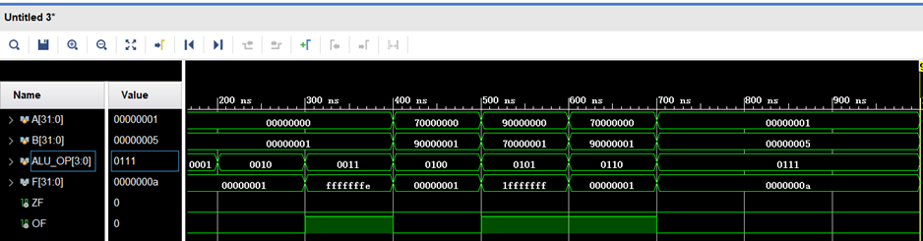
3、 仿真结果分析
逻辑与0ns: ALU_OP = 4'b0000;A= 32'h0000_0000;B=32'h0000_0001; F=0000_0000,ZF=1,OF=0;
逻辑或100ns: ALU_OP = 4'b0001;A= 32'h0000_0000;B=32'h0000_0001;F=0000_0001,ZF=0,OF=0;
逻辑异或200ns: ALU_OP = 4'b0010;A= 32'h0000_0000;B=32'h0000_0001; F=0000_0001,ZF=0,OF=0;
逻辑或非300ns: ALU_OP = 4'b0011;A= 32'h0000_0000;B=32'h0000_0001; F=ffff_fffe,ZF=0,OF=1;
算数加400ns: ALU_OP = 4'b0100;A= 32'h7000_0000;B=32'h9000_0001; F=0000_0001,ZF=0,OF=0;
算数减500ns: ALU_OP = 4'b0101;A= 32'h9000_0000;B=32'h7000_0001; F=1fff_ffff,ZF=0,OF=1;
若A<B,则F=1，否则输0 600ns: ALU_OP = 4'b0110;A= 32'h7000_0000;B=32'h9000_0001; F=0000_0001,ZF=0,OF=1;
B逻辑左移A所指定的位数700ns: ALU_OP = 4'b0111;A= 32'h0000_0001;B=32'h0000_0005; F=0000_000a,ZF=0,OF=0;
可见，符合ALU设计要求。
四、电路图（有就填，没有就不填）
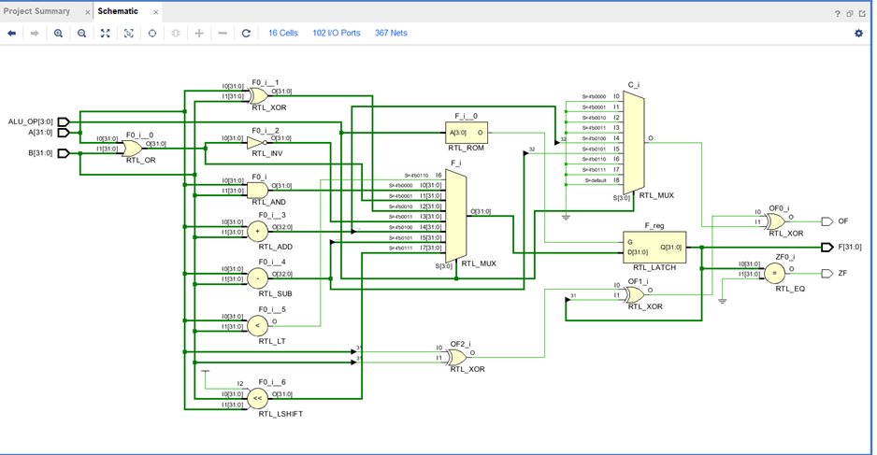
五、引脚配置（约束文件，有就填，没有就不填））
# 开启比特流压缩，优化 .bit 文件大小
set_property BITSTREAM.GENERAL.COMPRESS TRUE [current_design]

# Switch，开关
set_property PULLDOWN true [get_ports sw]
set_property IOSTANDARD LVCMOS18 [get_ports sw]
set_property PACKAGE_PIN T3 [get_ports {sw[1]}]
set_property PACKAGE_PIN U3 [get_ports {sw[2]}]
set_property PACKAGE_PIN T4 [get_ports {sw[3]}]
set_property PACKAGE_PIN V3 [get_ports {sw[4]}]
set_property PACKAGE_PIN V4 [get_ports {sw[5]}]
set_property PACKAGE_PIN W4 [get_ports {sw[6]}]
set_property PACKAGE_PIN Y4 [get_ports {sw[7]}]
set_property PACKAGE_PIN Y6 [get_ports {sw[8]}]
set_property PACKAGE_PIN W7 [get_ports {sw[9]}]
set_property PACKAGE_PIN Y8 [get_ports {sw[10]}]
set_property PACKAGE_PIN Y7 [get_ports {sw[11]}]
set_property PACKAGE_PIN T1 [get_ports {sw[12]}]
set_property PACKAGE_PIN U1 [get_ports {sw[13]}]
set_property PACKAGE_PIN U2 [get_ports {sw[14]}]
set_property PACKAGE_PIN W1 [get_ports {sw[15]}]
set_property PACKAGE_PIN W2 [get_ports {sw[16]}]
set_property PACKAGE_PIN Y1 [get_ports {sw[17]}]
set_property PACKAGE_PIN AA1 [get_ports {sw[18]}]
set_property PACKAGE_PIN V2 [get_ports {sw[19]}]
set_property PACKAGE_PIN Y2 [get_ports {sw[20]}]
set_property PACKAGE_PIN AB1 [get_ports {sw[21]}]
set_property PACKAGE_PIN AB2 [get_ports {sw[22]}]
set_property PACKAGE_PIN AB3 [get_ports {sw[23]}]
set_property PACKAGE_PIN AB5 [get_ports {sw[24]}]
set_property PACKAGE_PIN AA6 [get_ports {sw[25]}]
set_property PACKAGE_PIN R2 [get_ports {sw[26]}]
set_property PACKAGE_PIN R3 [get_ports {sw[27]}]
set_property PACKAGE_PIN T6 [get_ports {sw[28]}]
set_property PACKAGE_PIN R6 [get_ports {sw[29]}]
set_property PACKAGE_PIN U7 [get_ports {sw[30]}]
set_property PACKAGE_PIN AB7 [get_ports {sw[31]}]
set_property PACKAGE_PIN AB8 [get_ports {sw[32]}]

# Switch Button，按钮
set_property IOSTANDARD LVCMOS18 [get_ports swb]
set_property PACKAGE_PIN R4 [get_ports {swb[1]}]
set_property PACKAGE_PIN AA4 [get_ports {swb[2]}]
set_property PACKAGE_PIN AB6 [get_ports {swb[3]}]
set_property PACKAGE_PIN T5 [get_ports {swb[4]}]
set_property PACKAGE_PIN V8 [get_ports {swb[5]}]
set_property PACKAGE_PIN AA8 [get_ports {swb[6]}]

# LED
set_property IOSTANDARD LVCMOS18 [get_ports led]
set_property PACKAGE_PIN R1 [get_ports {led[1]}]
set_property PACKAGE_PIN P2 [get_ports {led[2]}]
set_property PACKAGE_PIN P1 [get_ports {led[3]}]
set_property PACKAGE_PIN N2 [get_ports {led[4]}]
set_property PACKAGE_PIN M1 [get_ports {led[5]}]
set_property PACKAGE_PIN M2 [get_ports {led[6]}]
set_property PACKAGE_PIN L1 [get_ports {led[7]}]
set_property PACKAGE_PIN J2 [get_ports {led[8]}]
set_property PACKAGE_PIN G1 [get_ports {led[9]}]
set_property PACKAGE_PIN E1 [get_ports {led[10]}]
set_property PACKAGE_PIN D2 [get_ports {led[11]}]
set_property PACKAGE_PIN A1 [get_ports {led[12]}]
set_property PACKAGE_PIN L3 [get_ports {led[13]}]
set_property PACKAGE_PIN G3 [get_ports {led[14]}]
set_property PACKAGE_PIN K4 [get_ports {led[15]}]
set_property PACKAGE_PIN G4 [get_ports {led[16]}]
set_property PACKAGE_PIN K1 [get_ports {led[17]}]
set_property PACKAGE_PIN J1 [get_ports {led[18]}]
set_property PACKAGE_PIN H2 [get_ports {led[19]}]
set_property PACKAGE_PIN G2 [get_ports {led[20]}]
set_property PACKAGE_PIN F1 [get_ports {led[21]}]
set_property PACKAGE_PIN E2 [get_ports {led[22]}]
set_property PACKAGE_PIN D1 [get_ports {led[23]}]
set_property PACKAGE_PIN B1 [get_ports {led[24]}]
set_property PACKAGE_PIN B2 [get_ports {led[25]}]
set_property PACKAGE_PIN N3 [get_ports {led[26]}]
set_property PACKAGE_PIN M3 [get_ports {led[27]}]
set_property PACKAGE_PIN K3 [get_ports {led[28]}]
set_property PACKAGE_PIN H3 [get_ports {led[29]}]
set_property PACKAGE_PIN N4 [get_ports {led[30]}]
set_property PACKAGE_PIN L4 [get_ports {led[31]}]
set_property PACKAGE_PIN J4 [get_ports {led[32]}]

# 数码管相关
set_property IOSTANDARD LVCMOS18 [get_ports seg]
set_property PACKAGE_PIN H19 [get_ports {seg[7]}]
set_property PACKAGE_PIN G20 [get_ports {seg[6]}]
set_property PACKAGE_PIN J22 [get_ports {seg[5]}]
set_property PACKAGE_PIN K22 [get_ports {seg[4]}]
set_property PACKAGE_PIN K21 [get_ports {seg[3]}]
set_property PACKAGE_PIN H20 [get_ports {seg[2]}]
set_property PACKAGE_PIN H22 [get_ports {seg[1]}]
set_property PACKAGE_PIN J21 [get_ports {seg[0]}]
set_property IOSTANDARD LVCMOS18 [get_ports which]
set_property PACKAGE_PIN N22 [get_ports {which[0]}]
set_property PACKAGE_PIN M21 [get_ports {which[1]}]
set_property PACKAGE_PIN M22 [get_ports {which[2]}]
set_property -dict {IOSTANDARD LVCMOS18 PACKAGE_PIN L21} [get_ports enable]
set_property -dict {IOSTANDARD LVCMOS18 PACKAGE_PIN H4} [get_ports clk]

# [Place 30-574] Poor placement for routing between an IO pin and BUFG.If this
# sub optimal condition is acceptable for this design, you may use the
# CLOCK_DEDICATED_ROUTE constraint in the .xdc file to demote this message to a
# WARNING. However, the use of this override is highly discouraged.
set_property CLOCK_DEDICATED_ROUTE FALSE [get_nets clk_IBUF]
set_property CLOCK_DEDICATED_ROUTE FALSE [get_nets swb_IBUF[1]]
set_property CLOCK_DEDICATED_ROUTE FALSE [get_nets swb_IBUF[2]]
set_property CLOCK_DEDICATED_ROUTE FALSE [get_nets swb_IBUF[3]]
set_property CLOCK_DEDICATED_ROUTE FALSE [get_nets swb_IBUF[4]]
set_property CLOCK_DEDICATED_ROUTE FALSE [get_nets swb_IBUF[5]]
set_property CLOCK_DEDICATED_ROUTE FALSE [get_nets swb_IBUF[6]]
六、实验分工
七、实验收获（心得体会等，请以个人为单位分别写）
实验中遇到如下几个问题，后找到解决方法
- ALU设计过程中，进位标志位不知道如何显示。
参考PPT中的公式。
- 第一次用板子，不知道如何书写约束文件，在尝试书写约束文件时，系统编译错误，无法生成比特流文件。
使用01_test中的约束文件，将变量名改为对应的名称。注意时序。

